“Science is the Religion for all”
EINSTEIN COLLEGE OF ENGINEERING


FIRE DETECTION USING
ARDUINO
Electronics and communication Engineering

Embedded System and IOT design ET3491

Project Report submitted by
C. Akshaya
S. Priya Dharshini
A.Rohini
S. Essai veni
M. Backiya Mukila

“Science is the Religion for all”
EINSTEIN COLLEGE OF ENGINEERING
Sir. C. V Raman Nagar, Tirunelveli-627012

BONAFIDE CERTIFICATE

Certified that this project report “FIRE DETECTION USING ARDUINO” is the Bonafide work of “C. AKSHAYA (950622106004), S. PRIYA DHARSHINI (950622106037), A. ROHINI (950622106043), S. ESSAI VENI (950622106019), M. BACKIYA MUKILA (950622106011)” who carried out the project work under supervision.

Staff-in-charge Head of the Department

Submitted for University Examination held on ……….......

Internal Examiner External Examiner

TABLE OF CONTENT

S.NO | TITLE | PAGE NO
1. | Abstract | 4
2. | Introduction | 4
3. | Internal working | 6
4. | External working | 7
5. | Working principal | 8
6. | Circuit diagram | 8
7. | List of components | 9
8. | Component working | 10
9. | Software implementation | 19
10. | Flow chart | 20
11. | Assembly method | 22
12. | Connection | 24
13. | Coding | 24
14. | Merits | 25
15. | Future enhancement | 26
16. | Application | 27
17. | Testing and result | 28
18. | Conclusion | 29
19. | Reference | 30

1.ABSTRACT

Fire detection systems are the most critical element of any building design these days. These days, reports of fire occurrences are frequent. In many instances, this could be the result of people's carelessness. Take a look at a few locations, such as gas stations, snack stores, homes, and primarily offices, etc. Every year, there are believed to be around ten thousand fire incidents. In this study, an automatic fire detection system using a sensor is introduced, taking all of these factors into account. Our suggested solution works differently from the current one, which uses a fire sensor to detect the fire. The current systems have fire alarms that sound an alert when a fire is discovered inside a certain area. The proposed system contains the fire alarm, Bread Board, LCD screen, Arduino in addition to that it sends a notification to our mobile and mail can be sent to the attached mail id which will be having the information of the accident-prone area, and also the information needed to alert the fire station about the incident.

2.INTRODUCTION

A fire alarm system is a system that is designed to warn people when there is fire, smokes, or any other harmful gas appear on the premise. The alarms are activated automatically or manually turned on with manual fire alarm activation devices such as manual call points or pull stations. The manual activation exist is to help people warn of a fire or harmful gas leak quickly as it may take some time for the sensors to kick in. The alarms can either be motorized bells or wall mounted sounder or horns. They can also be a speaker strobe which sound an alarm, followed by a voice urging evacuation message which alarming people on the situation and warning them not to use elevators if there is any. The fire alarms sounders can be set to different frequencies and tones depending on the country and the manufacturer. Some place needs a higher frequency and tone such as shopping malls and high-levelled building. Fire alarm system is crucial in every building as it can prevent any mishaps and can save lives. The system can sense heat and gas thus alarming people via buzzer, automated announcements, or alarming lights. It is faster than having to scream to alarm people of a fire or a gas leak. Basically, heat sensor will sense any temperature above the normal room temperature. The Arduino will be used as micro-controller to control the whole system. Once the temperature rise is detected, the signal will be sent to the buzzer or LED to alarm people. Thus, the people will be alarmed, and everyone will be able to evacuate safely. The fire alarm system is a safety system that warn people when the flame and flammable gas are detected. This system will automatically activate when the flame sensor and gas sensor detected the flame and gas. Then, the piezo buzzer will trigger and the LED will turn on to warn the people surrounding. In addition, the LCD also will display the status of this fire alarm system.

3.Internal Working

1. Sensor Operation

- The MQ-2 gas sensor contains a heating element and a chemical-sensitive layer that reacts with combustible gases like LPG, methane, smoke, and alcohol vapors.
- As the gas concentration increases, the sensor's resistance changes, generating a varying analog voltage.

2. Signal Processing by Arduino

- Arduino reads the sensor output through the analog input (A0).
- The analog value (usually 0–1023) is compared against a predefined threshold (e.g., 300).
- If the gas level exceeds the threshold, it indicates a potential fire or gas leak.

3. Decision and Output

If the condition is met:

- A buzzer is activated to sound an alarm.
- An LED is lit to provide a visual alert.
All readings can be monitored using the Serial Monitor for real-time debugging.
4.External Working

1. Environmental Interaction

- The system is placed in an environment like a kitchen or lab where it continuously monitors air quality.
- It reacts to real-world gas emissions or smoke from cooking, burning, or leaks.

2. Alert Mechanism

- Once gas is detected, the external buzzer or LED gives immediate warning to people nearby.
- The system can be enhanced to send remote alerts through Wi-Fi or GSM.

3. User Feedback

- Users can observe sensor readings through Serial Monitor or a mobile interface (in future upgrades).
- Based on alerts, users can take preventive action like ventilation or evacuation.

5.WORKING PRINCIPAL OF SYSTEM

The Arduino based fire alarm system operates by continuously monitoring environmental conditions using fire detection sensors (such as flame, smoke and temperature sensor). When a fire hazard a detected, the system triggers an alarm mechanism (buzzer) to notify users.

- Home safety system
- Fire industrial monitoring
- Offices and commercial buildings
- Hospitals & healthcare
- Smart cities & IoT motoring
- Agricultural & livestock farms

6.CIRCUIT DIAGRAM
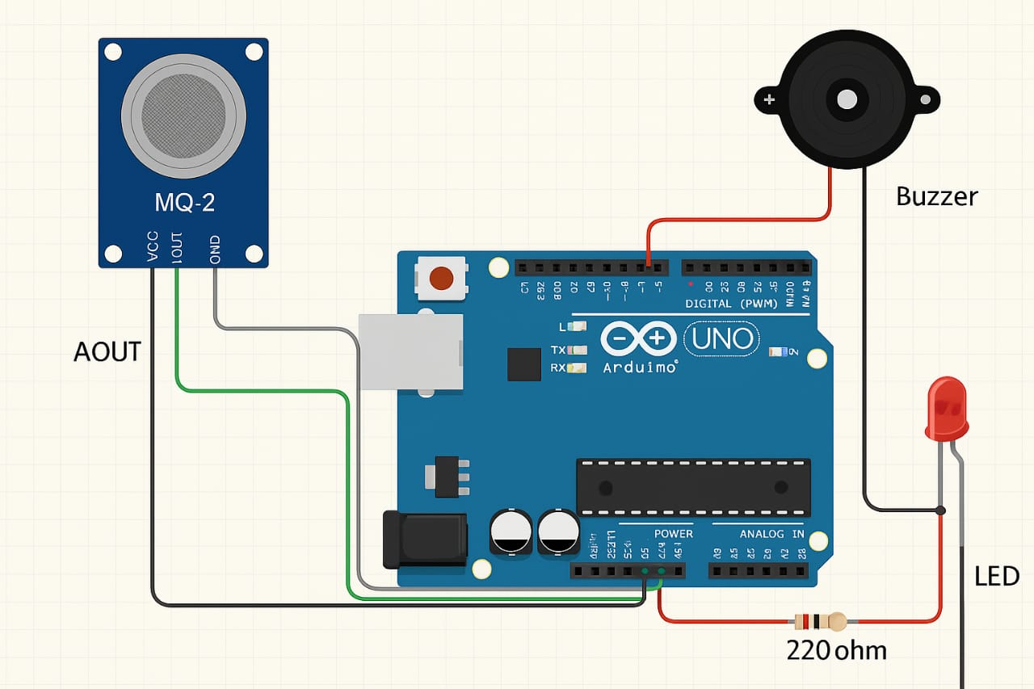
The circuit diagram for the fire detection system using Arduino consists of several key components interconnected on a breadboard. The Arduino board is at the center, connected to a gas sensor, a piezo sensor, a micro servo motor, and an LCD display. The gas sensor detects smoke or combustion gases, while the piezo sensor listens for fire-related sounds. When either sensor detects a fire hazard, the Arduino processes the data and triggers the servo motor to actuate a safety mechanism, such as closing a vent or activating an alarm. Vol-10 Issue-2 2024 IJARIIE-ISSN(O)-2395-4396 23177 ijariie.com 3354 The LCD display provides real-time feedback by showing sensor readings and alert messages, ensuring occupants are informed about potential fire risk.

7.LIST OF ELEMENTS
TABLEI.LIST OF ELEMENTS THAT ARE REQUIRED
COMPONENTS | QUANTITY
Arduino | 1
Micro servo motor | 1
Piezo sensor | 1
Gas sensor | 1
Bread board | 1
Connecting wires | As required

8. Components working
We will discuss briefly about the each and every component that is listed in the above table.

- Arduino:

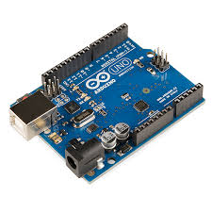

In this fire alarm system, the Arduino uno R3 ATMEGA328P has been used. The Arduino environment has two platform which are a development board and the software environment. A development board has 8-bit microcontroller, programming hardware, USB programming interface and input/output pin. For software development which is Integrated Development Environment (IDE) has crosscompiler, debugger, simulator and programmer. To make the programming code of the system, the code is upload from Arduino IDE to microcontroller (ATMEGA328P) at Arduino uno.

- Micro servo motor:

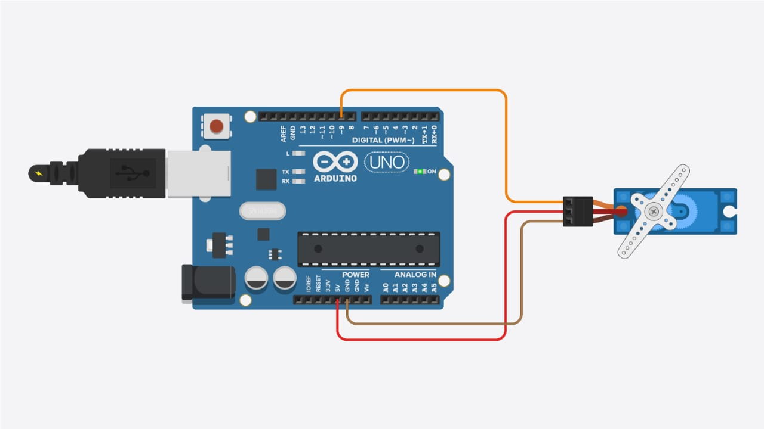

The working principle of a micro servo motor is based on the interaction between electrical signals and mechanical components, primarily involving a small DC motor, gears, a potentiometer, and control electronics.
Here's how it typically works:
1. DC Motor: At the core of a micro servo motor is a small DC motor. When electricity flows through the motor, it generates rotational motion.
2. Gears: The rotational motion from the DC motor is transferred to gears, which then amplify the torque and reduce the speed of rotation. Gears are crucial in servo motors as they provide the necessary mechanical advantage for precise control.
3. Potentiometer (Position Feedback Device): Inside the servo motor, there is a potentiometer or a similar position feedback device. This component provides feedback to the control electronics regarding the current position of the motor shaft. The potentiometer is mechanically coupled to the output shaft of the motor so that its resistance changes as the shaft rotates.
4. Control Electronics: The control electronics receive input signals, typically in the form of PWM (Pulse Width Modulation) signals, from an external controller, such as a microcontroller or a servo motor driver. These control signals determine the desired position or angle that the servo motor should rotate to.
5. Feedback Loop:
The control electronics compare the desired position with the actual position If there's a difference between the desired and actual positions, the control electronics adjust the voltage supplied to the motor to drive it in the required direction until the positions match.
6. Closed-Loop Control: Servo motors operate in a closed-loop control system. This means that they continuously monitor their own output and adjust their behaviour to achieve the desired output. The feedback mechanism provided by the potentiometer ensures accurate positioning and helps correct any deviations from the desired position.
7. Mechanical Output: The output shaft of the servo motor rotates to the desired position based on the control signals received by the control electronics. This rotational motion can be used to actuate various mechanisms, such as steering in RC vehicles, moving robot joints, or controlling camera gimbals.

- Piezo Electric Sensor:

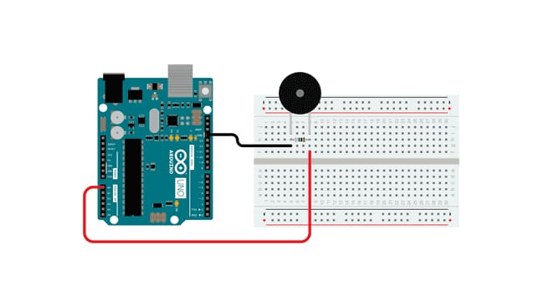
Piezoelectric sensors are fascinating devices that convert mechanical stress or pressure into electrical signals.
Here's how they work:
1. Piezoelectric Material: At the core of a piezoelectric sensor is a piezoelectric material, such as quartz, Rochelle salt, or certain ceramics. These materials exhibit the piezoelectric effect, which means they generate an electric charge in response to mechanical stress or pressure.
2. Crystalline Structure: Piezoelectric materials have a unique crystalline structure that allows them to generate electric charges when subjected to mechanical deformation. When pressure is applied to the material, it causes a slight distortion in the arrangement of atoms within the crystal lattice, resulting in the separation of positive and negative charges.
3. Generation of Electric Charge: When mechanical stress or pressure is applied to the piezoelectric material, it generates an electric charge across its surface. This charge is proportional to the amount of pressure applied and the sensitivity of the material.
4. Electrodes: To capture the electric charge generated by the piezoelectric material, electrodes are attached to its surface. These electrodes allow the electric charge to be conducted away from the material and used as an electrical signal.
5. Output Signal: The electric charge generated by the piezoelectric material is typically in the form of a voltage or current signal. This signal can be amplified and processed to measure the magnitude and duration of the applied pressure or mechanical stress.
6. Applications: Piezoelectric sensors find applications in various fields, including:
• Pressure sensing: Piezoelectric sensors can measure changes in pressure, making them useful in applications such as pressure monitoring in industrial processes, automotive tire pressure monitoring systems, and medical devices.
• Acceleration sensing: Piezoelectric sensors can detect changes in acceleration, allowing them to be used in devices like airbag deployment systems in automobiles and vibration monitoring systems.
• Force sensing: Piezoelectric sensors can measure force or load, making them valuable in applications such as forcesensitive touch screens, load cells in weighing scales, and structural health monitoring of bridges and buildings.
7. High Sensitivity: Piezoelectric sensors are known for their high sensitivity and fast response times. They can detect very small changes in pressure or mechanical stress, making them suitable for precise measurements in various applications.
In summary, piezoelectric sensors convert mechanic stress or pressure into electrical signals through the piezoelectric effect, allowing for sensitive and accurate measurement of various physical parameters.

4.Gas Sensor:

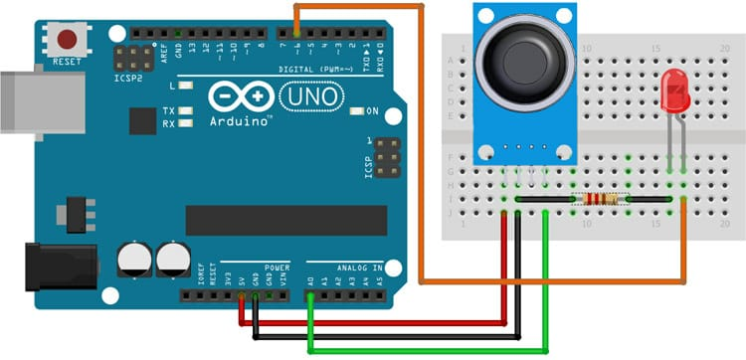

Gas sensors are vital components used to detect thepresence and concentration of gases in the air.
Here an overview of their construction and working principle:
Construction:
1. Gas-Sensitive Material: The heart of a gas sensor is a gas-sensitive material. This material undergoes changes in its electrical properties (e.g., resistance, capacitance) when it comes into contact with specific gases. Common gas-sensitive materials include metal oxides (e.g., tin dioxide), semiconducting polymers, and catalytic metals.
2. Substrate: The gas-sensitive material is typically deposited or coated onto a substrate, which provides mechanical support and electrical connections. The substrate can be made of materials like ceramic, glass, or silicon.
3. Electrodes: Electrodes are attached to the gas-sensitive material to measure the changes in its electrical properties. These electrodes allow the sensor to interface with external circuitry for signal processing and analysis.
4. Enclosure: Gas sensors are often housed in protective enclosures to shield them from environmental factors such as humidity, temperature variations, and mechanical damage. The enclosure may have openings or pores to allow the gas to reach the sensing element.
5. Heater Element (For Some Types): In certain gas sensor designs, especially those using metal oxide materials, a built-in heater element is included. The heater increases the operating temperature of the sensing element, promoting gas adsorption and enhancing sensor response.
Working Principle:
1. Gas Adsorption: When a gas comes into contact with the gas-sensitive material, it undergoes adsorption or absorption onto the surface of the material. This interaction changes the electrical conductivity or capacitance of the sensing element.
2. Change in Electrical Properties: The adsorption of gas molecules causes a change in the electrical properties of the gassensitive material. For example, in metal oxide-based sensors, the presence of reducing gases leads to a decrease in resistance, while oxidizing gases cause an increase in resistance.
3. Measurement: The electrodes connected to the gas-sensitive material detect the changes in electrical properties. By measuring parameters such as resistance, capacitance, or voltage, the sensor can determine the concentration of the target gas in the surrounding environment.
4. Signal Processing: The electrical signal from the sensor is often processed using additional circuitry, such as amplifiers, filters, and analog-to-digital converters. This processing may include calibration and compensation for environmental factors to improve the accuracy and reliability of the gas concentration measurement.
5. Output: Gas sensors typically provide an output signal proportional to the concentration of the target gas. This output can be displayed on a digital screen, transmitted to a control system for automated actions, or logged for further analysis. Gas sensors are widely used in various applications, including environmental monitoring, industrial safety, indoor air quality monitoring, automotive exhaust monitoring, and detection of hazardous gases in confined spaces. They play a crucial role in ensuring safety and efficiency in diverse settings.
5.Bread Board:


A breadboard, also known as a protoboard, is a fundamental tool used in electronics prototyping to create temporary circuits.
6.Connecting Wires:

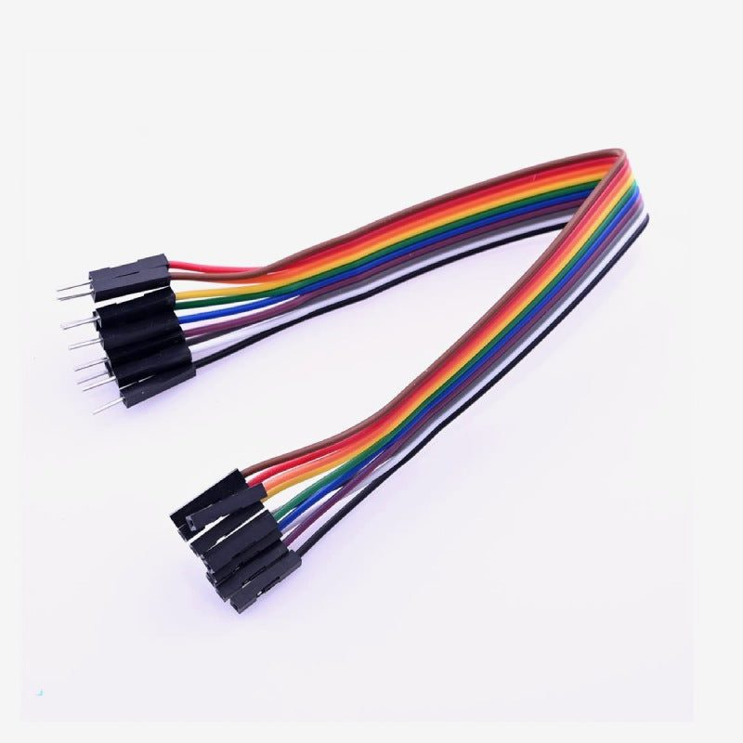

Connecting wires, also known simply as wires or jumper wires, are essential components in electronics and electrical engineering. They are used to establish electrical connections between various components such as microcontrollers, sensors, actuators, and other electronic devices.
9.SOFTWARE IMPLEMENTATION

The software implementation involves programming the Arduino to read data from the MQ-2 gas sensor, process it, and activate alerts when the gas concentration exceeds a set threshold.

DEVELOPMENT ENVIRONMENT:

- IDE used : Arduino IDE
- Language: Embedded C

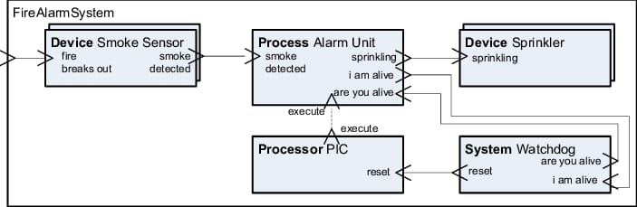

10.FLOW CHART
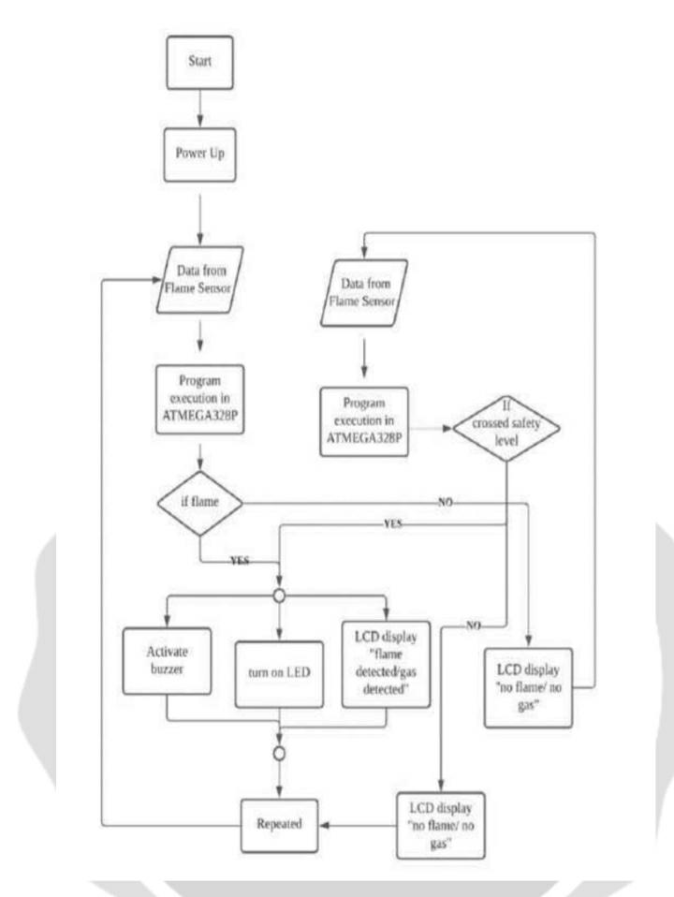

1.For flame sensor and gas sensor, the program will execute in microcontrollerATMEGA328P which pin A2 and A0 as input, respectively.2.

2.For buzzer, LED and LCD as output. LCD is connected to analog pin A4 and A5 while buzzer and LED is connected to digital pin 8 and pin 13 respectively.

3.Threshold is set at value 500.

4.If the flame sensor detects the flame (flame value500), buzzer and LED will not activate, and the LCD will display “FLAME: NO FLAME”.

5.If gas sensor detects the flammable gas or smoke (>500), buzzer and LED will activate and LED will display “GAS: GAS IS DETECTED”. While if the gas sensor does not detect the flammable gas or smoke will display “GAS: NO GAS”.

6.This program will repeat and loop.

11.ASSEMBLY METHOD

1.Prepared all components that used to make fire alarm system.
2.Put the piezo buzzer and gas sensor at breadboard.
3.For piezo buzzer, connect the positive pin to digital pin while negative to ground pin using jumping wire.
4.For gas sensor, connect the pin A0 to pin analog A0 at Arduino UNO.
5.Connect to analog pin A2 for flame sensor.
6.The LED is connected to pin 13
7. The LCD is connected to analog pin A4 and A5
8. Power up the Arduino with connect to laptop/PC.
9. Open software Arduino IDE and upload the sketch or program code to Arduino uno.
10. Then, light on the flame at flame sensor to see the output happen.
11. Then, turn on the flammable gas at gas sensor to see the output.

Piezo buzzer
Positive pin (+) = pin 8 Negative pin (-) = ground

LED
Anode = pin 13Cathode = ground

Flame sensor
A0 = pin A2GND = ground VCC = power 5 V

Gas sensor
A0 = pin A0GND = ground VCC = power 5 V

Liquid crystal (LCD)
GND = ground VCC = power 5 VSDA = pin A4SCL =pin A5

12.COMPONENT CONNECTION

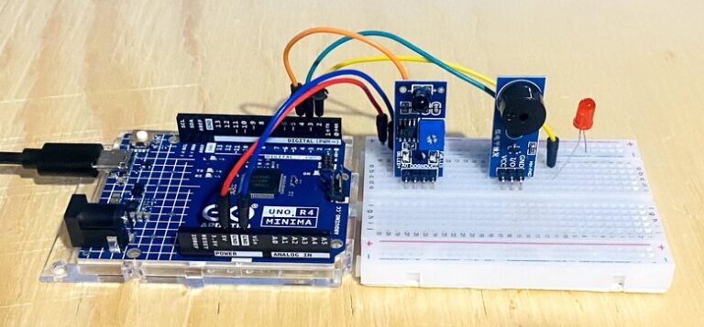

13.Coding

const int ledpin=10;
const int flamepin=A1;
const int buzpin=11;
const int threshold=200;
int flamesensvalue=0;
void setup() {
Serial.begin(9600);
pinMode(ledpin,OUTPUT);
pinMode(flamepin,INPUT);
pinMode(buzpin,OUTPUT);
}
void loop() {
flamesensvalue=analogRead(flamepin);
if (flamesensvalue<=threshold) {
digitalWrite(ledpin,HIGH);
tone(buzpin,100);
delay(1000);
}
else{
digitalWrite(ledpin,LOW);
noTone(buzpin);
}}

14. MERITS OF THIS PROJECT

- Early fire detetction.
- Low-cost implementation.
- Easy to build and modify.
- Real-time monitoring.
- Scalable.
- Educational value.
- Versatile use cases.

15. FUTURE ENHANCEMENTS

- Wi-fi connectivity (ESP32)
Send real-time alerts to smartphones or cloud dashboards using IoT platforms like Blynk, ThingSpeak or Firebase.

- AI/ML integration.
Use data patterns to predict and classify fire risk levels with higher accuracy.

- GSM module integration
Trigger SMS or call alerts in case of fire or gas leak, useful where internet is unavailable.

- Mobile app control.
Create custom app to monitor sensor readings, receive alerts and control the sytem remotely.

- Temperature and humidity monitoring.
Add sensors like DHT11 or DHT22 to detect rising temperatures along with gas levels for better fire prediction.

16. APPLICATIONS

- Home safety systems
Early detection of gas leaks and potential fires in kitchens or living spaces.

- Industrial safety.
Monitors hazardous gas levels in factories, chemical plants or storage rooms.
- Commercial building.
Adds an extra layer of fire safety in malls, offices and warehouses.

- Laboratories.
Alerts lab staff to harmful gas leaks or flammable chemical vapors.

- Smart iot security system.
Can be integrated into smart homes using wi-fi (ESP32) or GSM modules for remote alerts.

- Automotive applications.
Detects gas leaks or smoke in vehicles, especially those using LPG or CNG.
17. TESTING AND RESULT

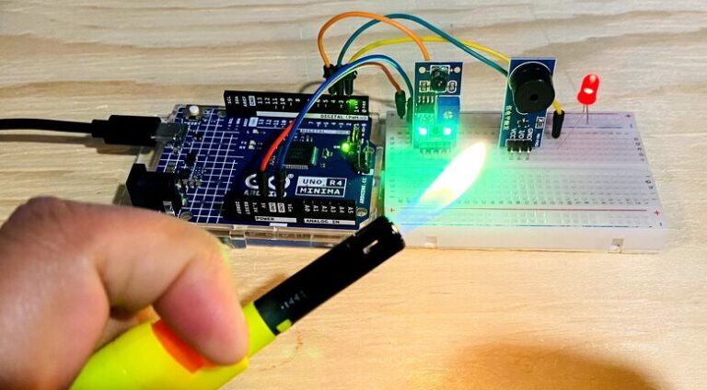

After several tests have been done towards our project, The Fire Alarm System has been able to be conducted according to the desired system. The system consists of two inputs, which are flame sensor and gas sensor. Starting off with the flame sensor, it detects the presence of the fire and it will send a signal to its output. In this case, the outputs are LED, Piezo Buzzer and the LCD Panel. The LED will light up and the buzzer will produce the sound after obtain the signal to aware the users about the presence of fire. The LCD Panel will display the information about the presence of fire. The second input, which is the gas sensor is a component that measures presences of the gas, which is smoke in this case. The type of gas sensor we use for this project is MQ-2. This type of gas sensor able to detects butane, methane, LPG and smoke. This gas sensor is placed at this fire alarm system to enhance to safety when there are fires. When the situation occurs, it will send a signal to its output, which is the buzzer. This buzzer acts as an alarm that reminds the users to be aware of the situation. Certain tests, improvements and changes were done to achieve the results mentioned above. The sensors have been tested and it work well as intended. This project certainly can be a huge helping to the society to prevent the unwanted situation. This alarm system can implement Fire Alarm requirement to maintain the safety and eliminate hazard.

18. Conclusion

The Arduino-based fire and gas detection system successfully demonstrates a low-cost, reliable solution for early fire warning. By utilizing an MQ-2 gas sensor, the system effectively detects combustible gases and smoke, triggering timely alerts through a buzzer or LED. This project not only enhances safety in residential and industrial environments but also serves as an excellent platform for learning embedded systems and sensor integration. With further enhancements such as IoT connectivity, GSM alerts, and flame detection, the system can be transformed into a comprehensive, real-time fire monitoring solution suitable for smart safety applications.
REFERENCES

[1] BNPB. Defenisi Bencana. bnpb.go.id. 2021. Available online: https://bnpb.go.id/definisi- bencana.
[2] Healey, Glenn, David Slater, Ted Lin, Ben Drda,and A. Donald Goedeke."A system for real-timtime fire detection." In Proceedings of IEEE Conference onComputer Vision and Pattern Recognition, pp.605-606. IEEE, 1993.
[3] Pack, Daniel J., Robert Avanzato, David J.AhlgrenAnd Igor M. Verner. "Fire-fighting mobilerobotics and interdisciplinary design comparative perspectives." IEEE Transactionson education 47, no. 3 (2004): 369-376
[4] Kamelia, L.; Ismail, N.; Firmansyah, A.A. Fire disaster early detection system in residential areas. J. Phys. Conf. Ser. 2019,1402, 044001. [CrossRef]
[5] Chien, Ting L., H. Guo, Kuo L. Su, and Sheng V. Shiau."Develop a multiple interface-based fire- fighting robot." In 2007 IEEE International Conference on Mechatronics, pp.1-6. IEEE, 2007.
[6] Liljeback, Pal, Oyvind Stavdahl, and Anders Beitnes."Snake Fighter-development of a water hydraulic fire Fighting snake robot." In 2006 9th International Conference on Control, Automation, Robotics and Vision, pp. 1-6. IEEE, 2006
[7] San-Miguel-Ayanz, Jesus, and Nicolas Ravail. "Active fire detection for fire emergency management: Potential and limitations for the operational use of remote sensing." Natural Hazards 35, no. 3 (2005): 361-376

